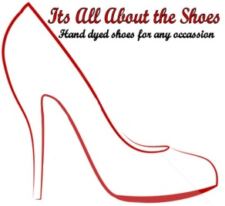

Name
Street Address
Town/City
County
Post Code
Telephone
Email
Date shoes are required for:
State Dyeing requirement:
Daylight
Artificial Light
Fabric Swatch (if fabric has a two tone effect, please indicate which thread/tone you desire)
Pricing
Standard Shoe Dyeing – returned within 21 days £18.00
Shoe Dying with Shoe Clips £25.00
Shoe Dying with custom design – Price on request.
This includes Hot Fix and Lace Applique.
Express Orders – returned with 5 working days from receipt of payment £25.00
Colour Matching Notes
For best results choose Ivory or Cream satin shoes. White Satin has a blue cast which affects the final colour.
Dyed fabric will look different in natural light as opposed to artificial light. Therefore please state (above) which you would prefer.
If fabric is two tone or shot please state which tone/shade you prefer.
Due to textural differences in fabrics the item will never be an exact colour match as sheen and texture change the tonal effect.
Dyeable shoes are NOT water resistant. The dyes used are water soluble, so if your shoes are exposed to moisture the dye will bleed. I CAN protect the shoes with a waterproof repellent if required. However this will NOT make the shoes completely waterproof but will prevent staining. If you opt for this treatment it is NOT possible to re-dye.
I can confirm that I have read the above information and accept that dying is undertaken at my own risk.
Signed: Date:

